

**ENTERTAINER DATA ANALYSIS**

## Entertainer Data Analysis

POW E R BI | PY T HO N

## Project Details

|  |  |
| --- | --- |
| Title | Entertainer Data Analysis |
| Technologies | Business Intelligence |
| Domain | Film and Entertainment |
| Project Difficulties level | Intermediate |
| Programming language used | Python, SQL |
| Others tools | PowerBi, Excel, Jupyter Notebook, MS PowerPoint |

Problem statement

Normal life can be stressful, and people need to relax. Being entertained by others is a wonderful way to take some time out of life. It can reduce stress and make life’s issues easier to face. The media and entertainment industry consists of film, television, radio, and print. These segments include movies, TV shows, radio shows, news, music, newspapers, magazines, and books. The entertainment industry is a group of sub-industries devoted to entertainment. The entertainment industry is used to describe the mass media companies that control the distribution and manufacture of mass media entertainment.

### Objective

The goal of this project is to develop a Power Bi Dashboard, which can be used for analysis

entertainer’s filmography and their career as well as movie analysis over the years.

### Benefits

* Entertainer’s filmography can be analyzed with a click
* Awards of the entertainers can be consumed by the end-user
* Different KPIs will indicate the main information about the entertainer
* Movie count trend or rating of the movie trend over the year can be consumed based on the filters applied

# Data preparation Flow

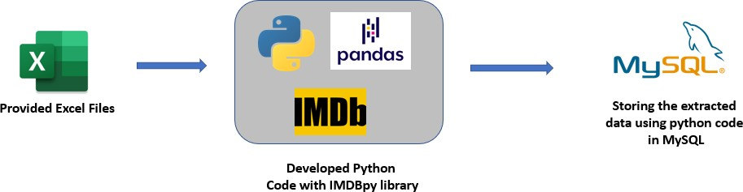

As the provided data is not sufficient for data analysis, I have populated data for the given entertainers and

stored them in a local MySQL database using IMDBpy and pandas library.

# Power BI Architecture

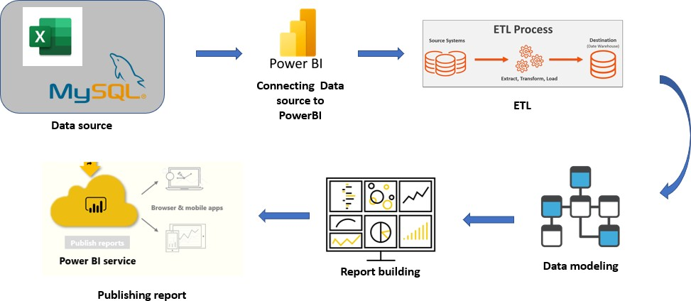

The overall architecture of the project, which was used to build the dashboard

### Dataset Information

#### Provided Dataset:

1. **Entertainer-Basic Info**: It consists of a list of **70** Entertainers' Name, Birth years, and Gender
2. **Entertainer-Breakthrough Info:** It consists of details about the 70 entertainers like breakthrough year, first major award, breakthrough movie name
3. **Entertainer-Last major work Info:** It consists of the details about the 70 entertainers' last major work and if died, the Year of death details.

**Populated Dataset:**

**Entertainers_basics_populated:**

* + Name: Entertainer’s name
  + DOB: Date of birth of the Entertainer
  + Height: Height of the entertainer
  + Nicknames: Nicknames of the entertainers, that are used by fans or the cinema industry
  + Quotes: Entertainers quote or statements they made in public
  + Mini-biography: Mini-biography of the entertainer
  + Trademark: Trademark style or behavior of the entertainer
  + Headshot: URL of the entertainers' headshot

**Entertainers_film_list:**

* + Entertainer name: Name of the entertainer
  + Movie name: The movie name which the entertainer acted
  + Year: Release year of the movie

#### Entertainers awards:

* + - Name: Entertainer’s name
    - Award: Award name
    - Year: Year of the award
    - Prize: Type of award
    - Category: Under which category the award has been given
    - Result: Whether the entertainer won the award or just a Nominee (Winner/Nominee)
    - Movie name: For which movie the award was given
    - Shared_with: If they shared the award with someone, their name

#### Entertainer salary:

* + - Name: Entertainer’s name
    - Movie name: Movie name of the salary they received
    - Year: Movie released year
    - Salary: Amount they received for that movie

Home Page

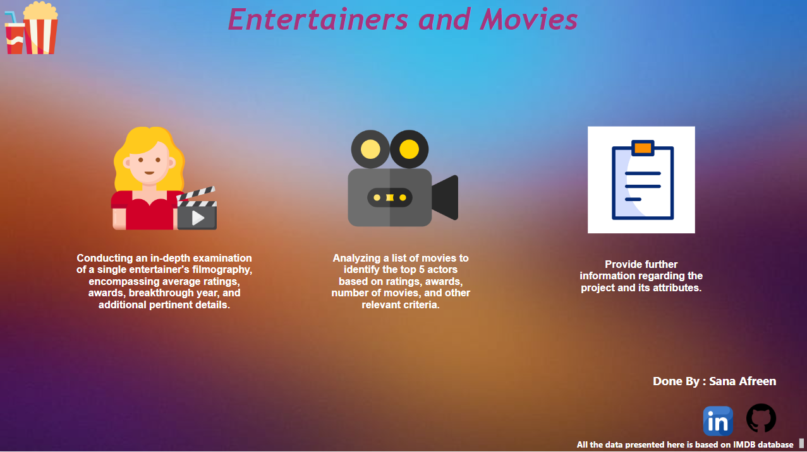

Entertainer Analysis Page

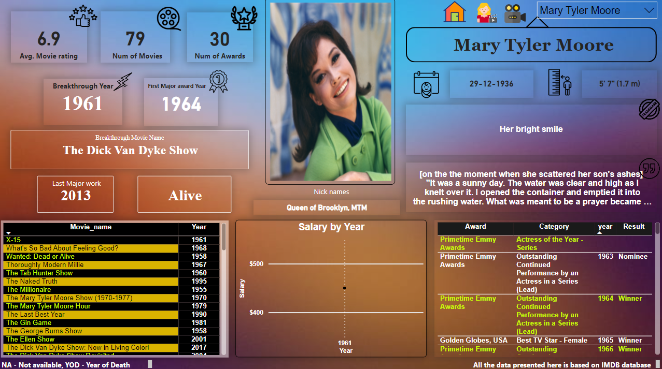

Movie Analysis Page

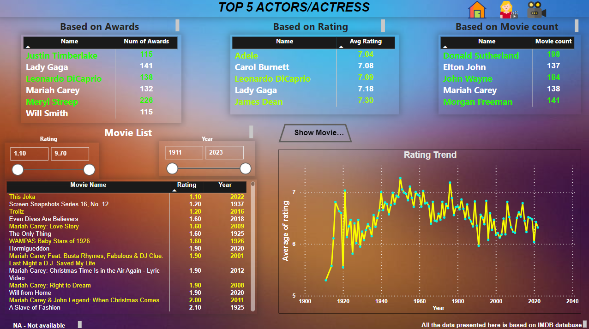

KPIs (Key Performance Indicators)

* + - * Average Movie rating of the Entertainer
      * Total number of movies acted by the Entertainer
      * Total number of awards
      * Breakthrough Movie year
      * Breakthrough Movie name
      * First major award year
      * Date of birth of the Entertainer
      * Height of the Entertainer
      * One of the famous Quote of the Entertainer
      * Trademarks of the Entertainer
      * Nicknames of the Entertainer

Some of the insights from the Report

* Meryl Streep is the entertainer who received the highest number of awards among other entertainers
* Top 6 entertainers who received most of the awards
  + Meryl Streep
  + Lady Gaga
  + Leonardo DiCaprio
  + Mariah Carey
  + Justin Timberlake
  + Will Smith
* James Dean has the highest average rating of movies among others
* The highest number of movies (55) released to date was in 1998
* The highest average rating of movies was in 1949
* Donald Sutherland acted in the highest number of movies to date, which was 198 movies

As it is an entertainer’s analysis project, based on the end-user need they can

consume a lot of insights from the dashboard.

* + For the filtering purpose based on the end user need, on the entertainer's analysis page, there is a drop-down filter to select the particular entertainer.
  + In the Movie analysis page, Include several filters like rating and year, so the end user can filter the data according to their interest

